Database management system report

Junjia Guo (jug44@pitt.edu)

Fei Qi ([feq5@pitt.edu](mailto:feq5@pitt.edu))

Zhaoji Huang (zhh34@pitt.edu)

1. E-commerce system

This E-commerce system is going to sell computers online. User can log in our system and search what they want and purchase it on the system.

1. System demand
   1. User type

There are three kinds of user in our system: home customer, business customer and administration.

* 1. Use case diagram for customer



Figure1 customer use case

* 1. Use case diagram for administration



Figure2 administration use case

* 1. Assumption

1: Administrations can’t sign in by themselves. An old administration can add a new admin.

2: Order status will change automatically when products arrive.

1. Conceptual design
   1. Entity

User:

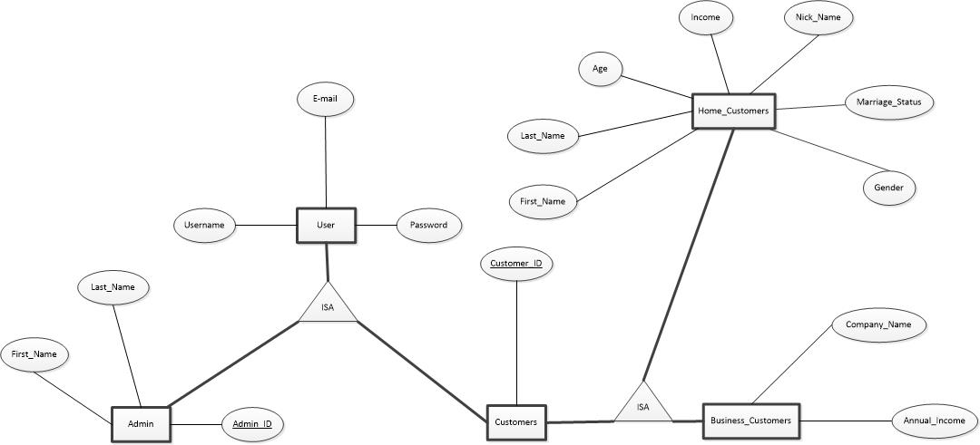

Figure 3 User

Business Category



Figure 3 Business Category

Address



Figure 4 Address

Billing Information



Figure 5 Billing Information

Orders



Figure 6 Orders

Cart



Figure 7 Cart

Products



Figure 8 Products

Hardware



Figure 9 Hardware

Hardware Category



Figure 10 Hardware Category

* 1. Relation



Figure 11 relation

* 1. Relational schema

Address:

|  |  |  |
| --- | --- | --- |
| Column | Type | Constrain |
| addressID | INT | PK |
| State | Varchar (20) | Not null |
| City | Varchar (45) | Not null |
| Street | Varchar (45) | Not null |
| Zip_code | INT | Not null, >10000 |

Admin:

|  |  |  |
| --- | --- | --- |
| Column | Type | Constrain |
| AdminID | INT | PK |
| First_name | Varchar (45) | Not null |
| Last_name | Varchar (45) | Not null |
| Username | Varchar (45) | Not null |
| Password | Varchar (45) | Not null |
| Email | Varchar (45) | Not null |

Billinginfo

|  |  |  |
| --- | --- | --- |
| Column | Type | Constrain |
| BillingID | INT | PK |
| Creditcard_number | Varchar (45) | Not null |
| Expire_month | INT | Not null; >=1&&<=12 |
| Expire_year | INT | Not null |

Business_category

|  |  |  |
| --- | --- | --- |
| Column | Type | Constrain |
| Business_categoryID | INT | PK |
| Business_category_name | Varchar (45) | Not null |

Business_customers

|  |  |  |
| --- | --- | --- |
| Column | Type | Constrain |
| CustomerID | INT | PK |
| Username | Varchar (45) | Not null |
| Password | Varchar (45) | Not null |
| Company_name | Varchar (45) | Not null |
| Emai | Varchar (45) | Not null |
| Annual_income | INT | Not null; default 0;>=0 |
| Business_categoryID | INT | FK,  business_category(Business_categoryID) |

Cart

|  |  |  |
| --- | --- | --- |
| Column | Type | Constrain |
| CustomerID | INT | PK |
| ProductID | INT | PK |
| Quantity | INT | Not null; >0 |

Customers_have_address

|  |  |  |
| --- | --- | --- |
| Column | Type | Constrain |
| CustomerID | INT | Not null |
| AddressID | INT | Not null |

Customers_have_billinginfo

|  |  |  |
| --- | --- | --- |
| Column | Type | Constrain |
| CustomerID | INT | Not null |
| BillingID | INT | Not null |

Hardware_category

|  |  |  |
| --- | --- | --- |
| Column | Type | Constrain |
| Hardware_categoryID | INT | PK |
| Hardware_category_name | Varchar (45) | Not null |

Hardwares

|  |  |  |
| --- | --- | --- |
| Column | Type | Constrain |
| HardwareID | INT | PK |
| Hardware_name | Varchar (45) | Not null |
| Hardware_company | Varchar (45) | Not null |
| Hardware_categoryID | INT | FK, Hardware_category(Hardware_categoryID) |

Home_customers

|  |  |  |
| --- | --- | --- |
| Column | Type | Constrain |
| CustomerID | INT | PK |
| Username | Varchar (45) | Not null |
| Password | Varchar (45) | Not null |
| First_name | Varchar (45) | Not null |
| Last_name | Varchar (45) | Not null |
| Nick_name | Varchar (45) | Not null |
| Email | Varchar (45) | Not null |
| Gender | Varchar (20) | Not null |
| Age | INT | Not null, >=0 |
| Income | INT | Not null >=0 |
| Marriage_status | Varchar (20) | Not null; default unknown |

Manage

|  |  |  |
| --- | --- | --- |
| Column | Type | Constrain |
| AdminID | INT | Not null |
| Productid | INT | Not null |
| Since | Datetime | Not null |

Orders

|  |  |  |
| --- | --- | --- |
| Column | Type | Constrain |
| OrderID | INT | PK |
| ProdeuctID | INT | FK, Products (ProdeuctID) |
| CustomerID | INT | Not null |
| BillingID | INT | FK, billingInfo(BillingID) |
| Ship_addressID | INT | FK, Address (addressID) |
| Billing_addressID | INT | FK, Address (addressID) |
| Since | Datetime | Not null |
| Quantity | INT | Not null, default 0 |
| Price | Float | Not null, default 0.1 |
| Status | INT | NOT null; default 0; 0:processing, 1:done |

Products

|  |  |  |
| --- | --- | --- |
| Column | Type | Constrain |
| Productid | INT | PK |
| Inventory_amount | INT | Not null; >=0 |
| Product_name | Varchar (45) | Not null |
| Price | Float | Not null; >0 |
| Home_discount | INT | Not null; >0, <=100 |
| Business_discount | INT | Not null; >0, <=100 |
| Status | INT | Not null; 1:avliable 0:unavliable |
| Sales_volume | Int | Not null; default 0 |

Products_have_hardware

|  |  |  |
| --- | --- | --- |
| Column | Type | Constrain |
| Productid | INT | Not null |
| HardwareID | INT | Not null |

1. physical design and part of initialize data

SET SQL_MODE = "NO_AUTO_VALUE_ON_ZERO";

SET time_zone = "+00:00";

-- Database: `ecommerce`

CREATE DATABASE IF NOT EXISTS `ecommerce` DEFAULT CHARACTER SET utf8 COLLATE utf8_general_ci;

USE `ecommerce`;

DROP TABLE IF EXISTS `address`;

CREATE TABLE `address` (

`addressID` int(11) NOT NULL,

`state` varchar(20) NOT NULL,

`city` varchar(45) NOT NULL,

`street` varchar(45) NOT NULL,

`zip_code` int(11) NOT NULL

) ENGINE=InnoDB DEFAULT CHARSET=utf8;

INSERT INTO `address` (`addressID`, `state`, `city`, `street`, `zip_code`) VALUES

(100, 'PA', 'Pittsburgh', '4720 Centre Ave, Apt 4E', 15213);

DROP TABLE IF EXISTS `admin`;

CREATE TABLE `admin` (

`adminID` int(15) NOT NULL,

`first_name` varchar(45) NOT NULL,

`last_name` varchar(45) NOT NULL,

`username` varchar(45) NOT NULL,

`password` varchar(45) NOT NULL,

`email` varchar(45) NOT NULL

) ENGINE=InnoDB DEFAULT CHARSET=utf8;

INSERT INTO `admin` (`adminID`, `first_name`, `last_name`, `username`, `password`, `email`) VALUES

(1, 'DONALD', 'TRUMP', 'President', 'donaldtrump', 'dt@whitehouse.gov');

DROP TABLE IF EXISTS `billinginfo`;

CREATE TABLE `billinginfo` (

`billingID` int(11) NOT NULL,

`creditcard_number` varchar(20)NOT NULL,

`expire_month` int(11) NOT NULL,

`expire_year` int(11) NOT NULL

) ENGINE=InnoDB DEFAULT CHARSET=utf8;

INSERT INTO `billinginfo` (`billingID`, `creditcard_number`, `expire_month`, `expire_year`) VALUES

(2, '88888888888888888', 12, 2019);

DROP TABLE IF EXISTS `business_category`;

CREATE TABLE `business_category` (

`business_categoryID` int(11) NOT NULL,

`business_category_name` varchar(45) NOT NULL

) ENGINE=InnoDB DEFAULT CHARSET=utf8;

DROP TABLE IF EXISTS `business_customers`;

CREATE TABLE `business_customers` (

`customerID` int(11) NOT NULL,

`username` varchar(45) NOT NULL,

`password` varchar(45) NOT NULL,

`company_name` varchar(45) NOT NULL,

`email` varchar(45) NOT NULL,

`annual_income` int(11) NOT NULL DEFAULT '0',

`business_categoryID` int(11) NOT NULL

) ENGINE=InnoDB DEFAULT CHARSET=utf8;

DROP TABLE IF EXISTS `cart`;

CREATE TABLE `cart` (

`customerID` int(11) NOT NULL,

`productID` int(11) NOT NULL,

`quantity` int(11) NOT NULL

) ENGINE=InnoDB DEFAULT CHARSET=utf8;

DROP TABLE IF EXISTS `customers_have_address`;

CREATE TABLE `customers_have_address` (

`addressID` int(11) NOT NULL,

`customerID` int(11) NOT NULL

) ENGINE=InnoDB DEFAULT CHARSET=utf8;

INSERT INTO `customers_have_address` (`addressID`, `customerID`) VALUES

(100, 10001);

DROP TABLE IF EXISTS `customers_have_billinginfo`;

CREATE TABLE `customers_have_billinginfo` (

`billingID` int(11) NOT NULL,

`customerID` int(11) NOT NULL

) ENGINE=InnoDB DEFAULT CHARSET=utf8;

INSERT INTO `customers_have_billinginfo` (`billingID`, `customerID`) VALUES

(2, 10001);

DROP TABLE IF EXISTS `hardwares`;

CREATE TABLE `hardwares` (

`hardwareID` int(11) NOT NULL,

`hardware_name` varchar(45) NOT NULL,

`hardware_company` varchar(45) NOT NULL,

`hardware_categoryID` int(11) NOT NULL

) ENGINE=InnoDB DEFAULT CHARSET=utf8;

INSERT INTO `hardwares` (`hardwareID`, `hardware_name`, `hardware_company`, `hardware_categoryID`) VALUES

(1, 'i7', 'Intel', 1),

(2, 'i5', 'Intel', 1),

(3, 'i3', 'Intel', 1),

(4, 'AMD', 'AMD', 1),

(5, 'Graphics Media Accelerator', 'A', 2),

(6, 'Special Display Card', 'A', 2),

(7, 'Dual Video Card', 'A', 2),

(8, '17 inch+ screen', 'A', 3),

(9, '15 inch screen', 'A', 3),

(10, '14 inch screen', 'A', 3),

(11, '13 inch screen', 'A', 3),

(12, '12 inch screen', 'A', 3),

(13, '11 inch- screen', 'A', 3),

(14, '32GB+ ROM', 'A', 4),

(15, '16GB ROM', 'A', 4),

(16, '8GB ROM', 'A', 4),

(17, '4GB ROM ', 'A', 4),

(18, '2GB ROM', 'A', 4),

(19, '1TB Disk', 'A', 5),

(20, '500GB Disk', 'A', 5),

(21, '512GB SSD', 'A', 5),

(22, '256GB SSD', 'A', 5),

(23, '128GB SSD', 'A', 5),

(24, '4K/3K/2K Resolution', 'A', 6),

(25, '1920*1080 Full HD', 'A', 6),

(26, '1366*768 Screen', 'A', 6),

(27, 'Other Screen', 'A', 6),

(28, 'Bluetooth 4.2', 'A', 7),

(29, 'Bluetooth 4.1', 'A', 7),

(30, 'Bluetooth 4.0 or less', 'A', 7);

DROP TABLE IF EXISTS `hardware_category`;

CREATE TABLE `hardware_category` (

`hardware_categoryID` int(11) NOT NULL,

`hardware_category_name` varchar(45) NOT NULL

) ENGINE=InnoDB DEFAULT CHARSET=utf8;

INSERT INTO `hardware_category` (`hardware_categoryID`, `hardware_category_name`) VALUES

(1, 'CPU'),

(2, 'GPU'),

(3, 'screen_size'),

(4, 'ROM'),

(5, 'hard_disk'),

(6, 'screen_resolution'),

(7, 'bluetooth');

DROP TABLE IF EXISTS `home_customers`;

CREATE TABLE `home_customers` (

`customerID` int(11) NOT NULL,

`username` varchar(45) NOT NULL,

`password` varchar(45) NOT NULL,

`first_name` varchar(45) NOT NULL,

`last_name` varchar(45) NOT NULL,

`nick_name` varchar(45) NOT NULL,

`email` varchar(45) NOT NULL,

`gender` varchar(20) NOT NULL,

`age` int(11) NOT NULL DEFAULT '0',

`income` int(11) DEFAULT '0',

`marriage_status` varchar(20) DEFAULT 'unknown'

) ENGINE=InnoDB DEFAULT CHARSET=utf8;

INSERT INTO `home_customers` (`customerID`, `username`, `password`, `first_name`, `last_name`, `nick_name`, `email`, `gender`, `age`, `income`, `marriage_status`) VALUES

(10001, 'gjj', '1234', 'Junjia', 'Guo', 'Jeff', 'jug44@pitt.edu', 'male', 24, -11, 'no');

DROP TABLE IF EXISTS `manage`;

CREATE TABLE `manage` (

`since` datetime NOT NULL,

`adminID` int(11) NOT NULL,

`productID` int(11) NOT NULL

) ENGINE=InnoDB DEFAULT CHARSET=utf8;

INSERT INTO `manage` (`since`, `adminID`, `productID`) VALUES

('2016-12-05 00:00:00', 1, 1),

('2016-12-05 00:00:00', 1, 2),

('2016-12-05 00:00:00', 1, 3);

DROP TABLE IF EXISTS `orders`;

CREATE TABLE `orders` (

`orderID` int(11) NOT NULL,

`productID` int(11) NOT NULL,

`customerID` int(11) NOT NULL,

`billingID` int(11) NOT NULL,

`ship_addressID` int(11) NOT NULL,

`billing_addressID` int(11) NOT NULL,

`since` datetime NOT NULL,

`quantity` int(11) NOT NULL DEFAULT '0',

`price` float NOT NULL DEFAULT '0.1',

`status` int(11) NOT NULL DEFAULT '0'COMMENT 'status: 0: processing , 1:done'

) ENGINE=InnoDB DEFAULT CHARSET=utf8;

DROP TABLE IF EXISTS `products`;

CREATE TABLE `products` (

`productID` int(11) NOT NULL,

`inventory_amount` int(11) NOT NULL,

`product_name` varchar(45) NOT NULL,

`price` float NOT NULL,

`home_discount` float DEFAULT '100',

`business_discount` float DEFAULT '100',

`status` int(11) DEFAULT '1' COMMENT 'status: 0: off , 1:on',

`sales_volume` int(11) NOT NULL DEFAULT '0'

) ENGINE=InnoDB DEFAULT CHARSET=utf8;

INSERT INTO `products` (`productID`, `inventory_amount`, `product_name`, `price`, `home_discount`, `business_discount`, `status`) VALUES

(1, 3, 'Hardware Test', 1000, 99, 96, 1 ),

(2, 3, 'Hardware Test', 1000, 99, 96, 1 ),

(3, 3, 'Hardware Test', 1000, 99, 96, 1);

DROP TABLE IF EXISTS `products_have_hardware`;

CREATE TABLE `products_have_hardware` (

`productID` int(11) NOT NULL,

`hardwareID` int(11) NOT NULL

) ENGINE=InnoDB DEFAULT CHARSET=utf8;

INSERT INTO `products_have_hardware` (`productID`, `hardwareID`) VALUES

(1, 1),

(1, 8),

(1, 14),

(1, 19),

(1, 21),

(1, 24),

(2, 1),

(2, 25),

(3, 1),

(3, 15);

-- Indexes for dumped tables

-- Indexes for table `address`

ALTER TABLE `address`

ADD PRIMARY KEY (`addressID`);

-- Indexes for table `admin`

ALTER TABLE `admin`

ADD PRIMARY KEY (`adminID`);

-- Indexes for table `billinginfo`

ALTER TABLE `billinginfo`

ADD PRIMARY KEY (`billingID`);

-- Indexes for table `business_category`

ALTER TABLE `business_category`

ADD PRIMARY KEY (`business_categoryID`);

-- Indexes for table `business_customers`

ALTER TABLE `business_customers`

ADD PRIMARY KEY (`customerID`),

ADD KEY `category_ID` (`business_categoryID`);

-- Indexes for table `cart`

ALTER TABLE `cart`

ADD PRIMARY KEY (`customerID`,`productID`);

-- Indexes for table `customers_have_address`

ALTER TABLE `customers_have_address`

ADD PRIMARY KEY (`addressID`,`customerID`);

-- Indexes for table `customers_have_billinginfo`

ALTER TABLE `customers_have_billinginfo`

ADD PRIMARY KEY (`billingID`,`customerID`);

-- Indexes for table `hardwares`

ALTER TABLE `hardwares`

ADD PRIMARY KEY (`hardwareID`),

ADD KEY `fk_hardwares_hardware_category1_idx` (`hardware_categoryID`);

-- Indexes for table `hardware_category`

ALTER TABLE `hardware_category`

ADD PRIMARY KEY (`hardware_categoryID`);

-- Indexes for table `home_customers`

ALTER TABLE `home_customers`

ADD PRIMARY KEY (`customerID`);

-- Indexes for table `manage`

ALTER TABLE `manage`

ADD PRIMARY KEY (`adminID`,`productID`,`since`);

-- Indexes for table `orders`

ALTER TABLE `orders`

ADD PRIMARY KEY (`orderID`),

ADD KEY `fk_order_products1_idx` (`productID`),

ADD KEY `fk_order_billinginfo1_idx` (`billingID`),

ADD KEY `fk_order_address1_idx` (`ship_addressID`),

ADD KEY `fk_order_address2_idx` (`billing_addressID`);

-- Indexes for table `products`

ALTER TABLE `products`

ADD PRIMARY KEY (`productID`);

-- Indexes for table `products_have_hardware`

ALTER TABLE `products_have_hardware`

ADD PRIMARY KEY (`productID`,`hardwareID`);

-- Indexes for table `supply`

ALTER TABLE `address`

MODIFY `addressID` int(11) NOT NULL AUTO_INCREMENT, AUTO_INCREMENT=101;

ALTER TABLE `admin`

MODIFY `adminID` int(15) NOT NULL AUTO_INCREMENT, AUTO_INCREMENT=2;

ALTER TABLE `billinginfo`

MODIFY `billingID` int(11) NOT NULL AUTO_INCREMENT, AUTO_INCREMENT=3;

ALTER TABLE `business_category`

MODIFY `business_categoryID` int(11) NOT NULL AUTO_INCREMENT;

ALTER TABLE `hardwares`

MODIFY `hardwareID` int(11) NOT NULL AUTO_INCREMENT, AUTO_INCREMENT=31;

ALTER TABLE `hardware_category`

MODIFY `hardware_categoryID` int(11) NOT NULL AUTO_INCREMENT, AUTO_INCREMENT=8;

ALTER TABLE `home_customers`

MODIFY `customerID` int(11) NOT NULL AUTO_INCREMENT, AUTO_INCREMENT=10002;

ALTER TABLE `orders`

MODIFY `orderID` int(11) NOT NULL AUTO_INCREMENT;

ALTER TABLE `products`

MODIFY `productID` int(11) NOT NULL AUTO_INCREMENT, AUTO_INCREMENT=4;

ALTER TABLE `business_customers`

ADD CONSTRAINT `business_customers_ibfk_1` FOREIGN KEY (`business_categoryID`) REFERENCES `business_category` (`business_categoryID`) ON UPDATE CASCADE;

ALTER TABLE `hardwares`

ADD CONSTRAINT `fk_hardwares_hardware_category1` FOREIGN KEY (`hardware_categoryID`) REFERENCES `hardware_category` (`hardware_categoryID`) ON UPDATE CASCADE;

ALTER TABLE `orders`

ADD CONSTRAINT `fk_order_address1` FOREIGN KEY (`ship_addressID`) REFERENCES `address` (`addressID`) ON DELETE NO ACTION ON UPDATE NO ACTION,

ADD CONSTRAINT `fk_order_address2` FOREIGN KEY (`billing_addressID`) REFERENCES `address` (`addressID`) ON DELETE NO ACTION ON UPDATE NO ACTION,

ADD CONSTRAINT `fk_order_billinginfo1` FOREIGN KEY (`billingID`) REFERENCES `billinginfo` (`billingID`) ON DELETE NO ACTION ON UPDATE NO ACTION,

ADD CONSTRAINT `fk_order_products1` FOREIGN KEY (`productID`) REFERENCES `products` (`productID`) ON DELETE NO ACTION ON UPDATE NO ACTION;

1. Implement
   1. Front-end design and front-end to back-end connection

We use php and html to build this system. Html send value it gets from front desk via post function and in php we use $_post to get the value. We can save it as local variable or use session to set global variable. From example, when user login successfully, php will start a session to turn username and customerID as global variable. Every time we use username or customerID we can get from session. When user choose to logout the session will clear.

* 1. System overview

Sign in

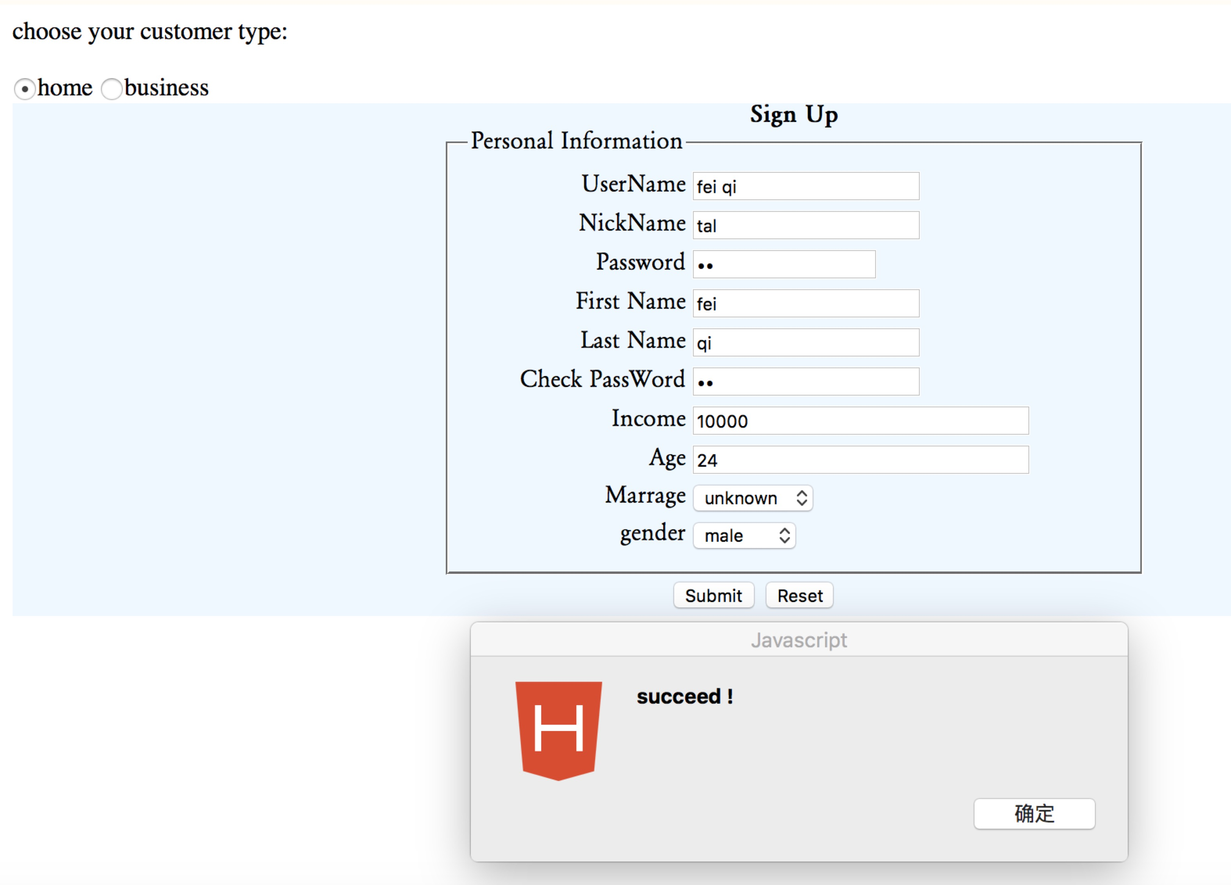

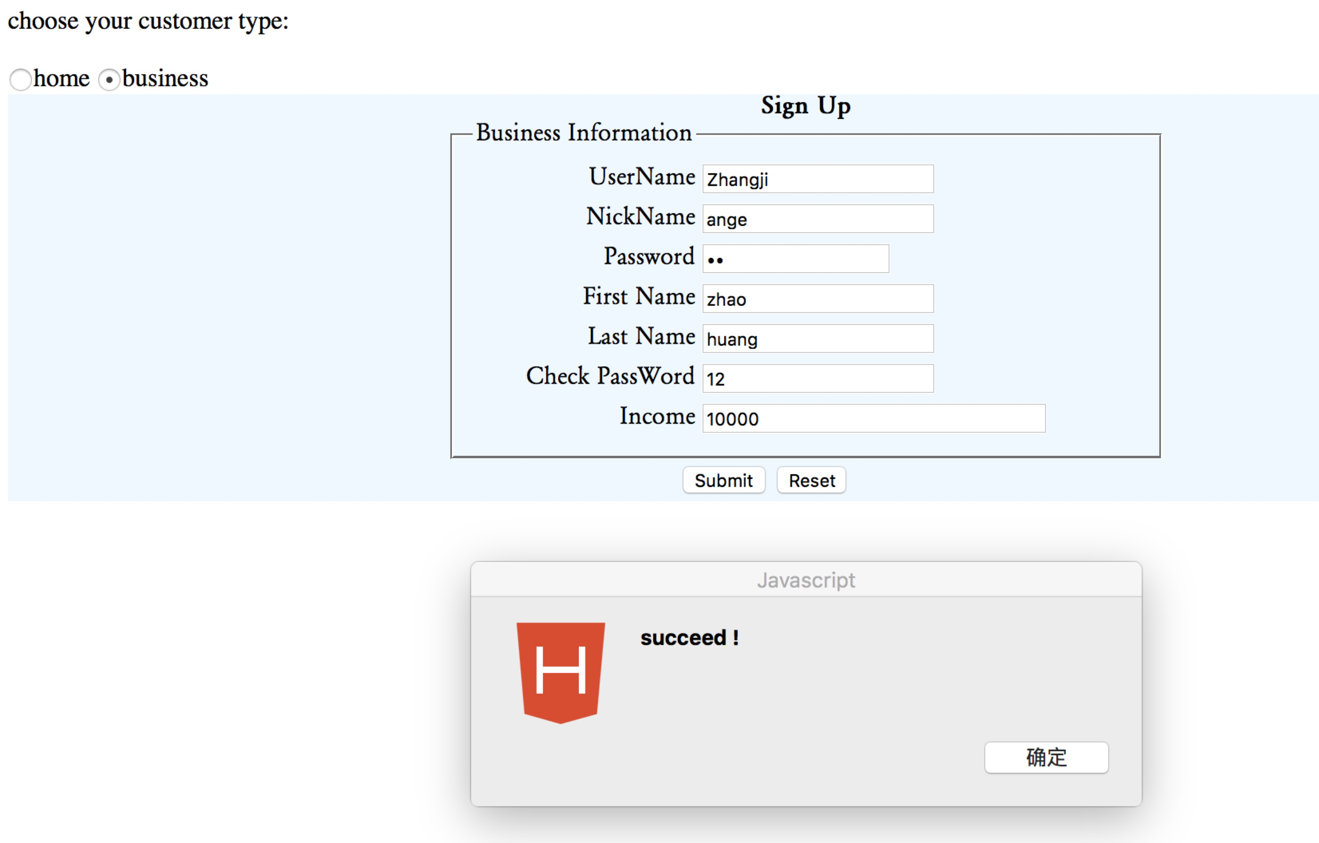

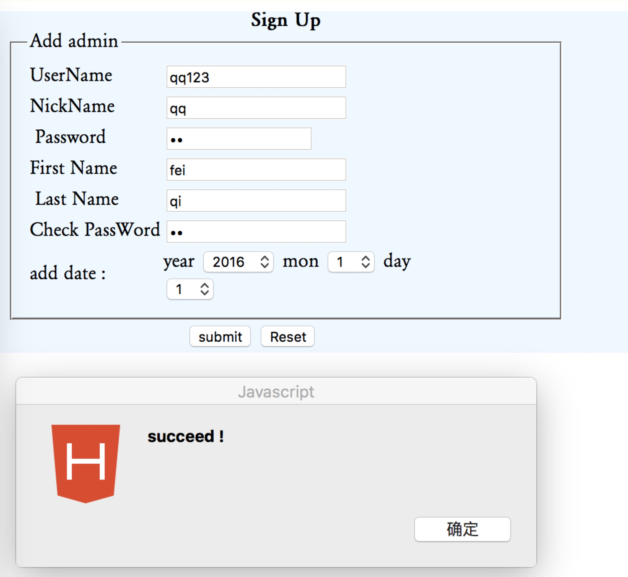

Login

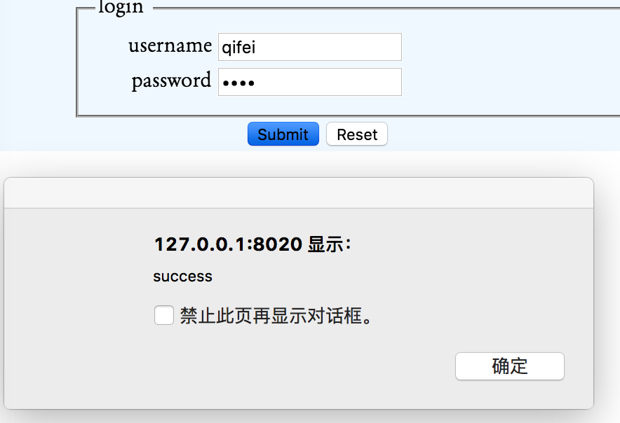

Add address information

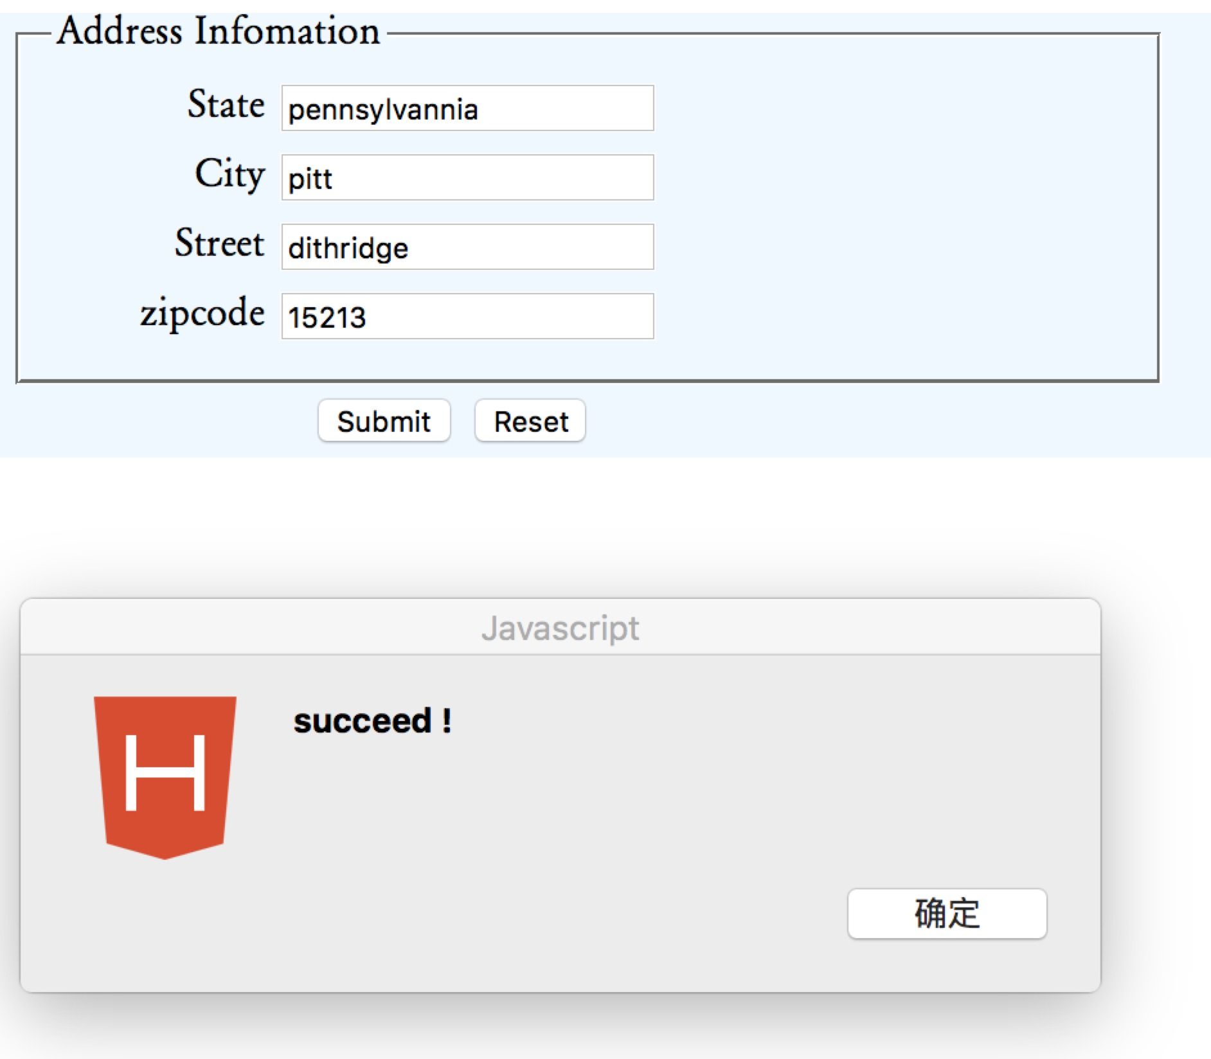

Add Billing information

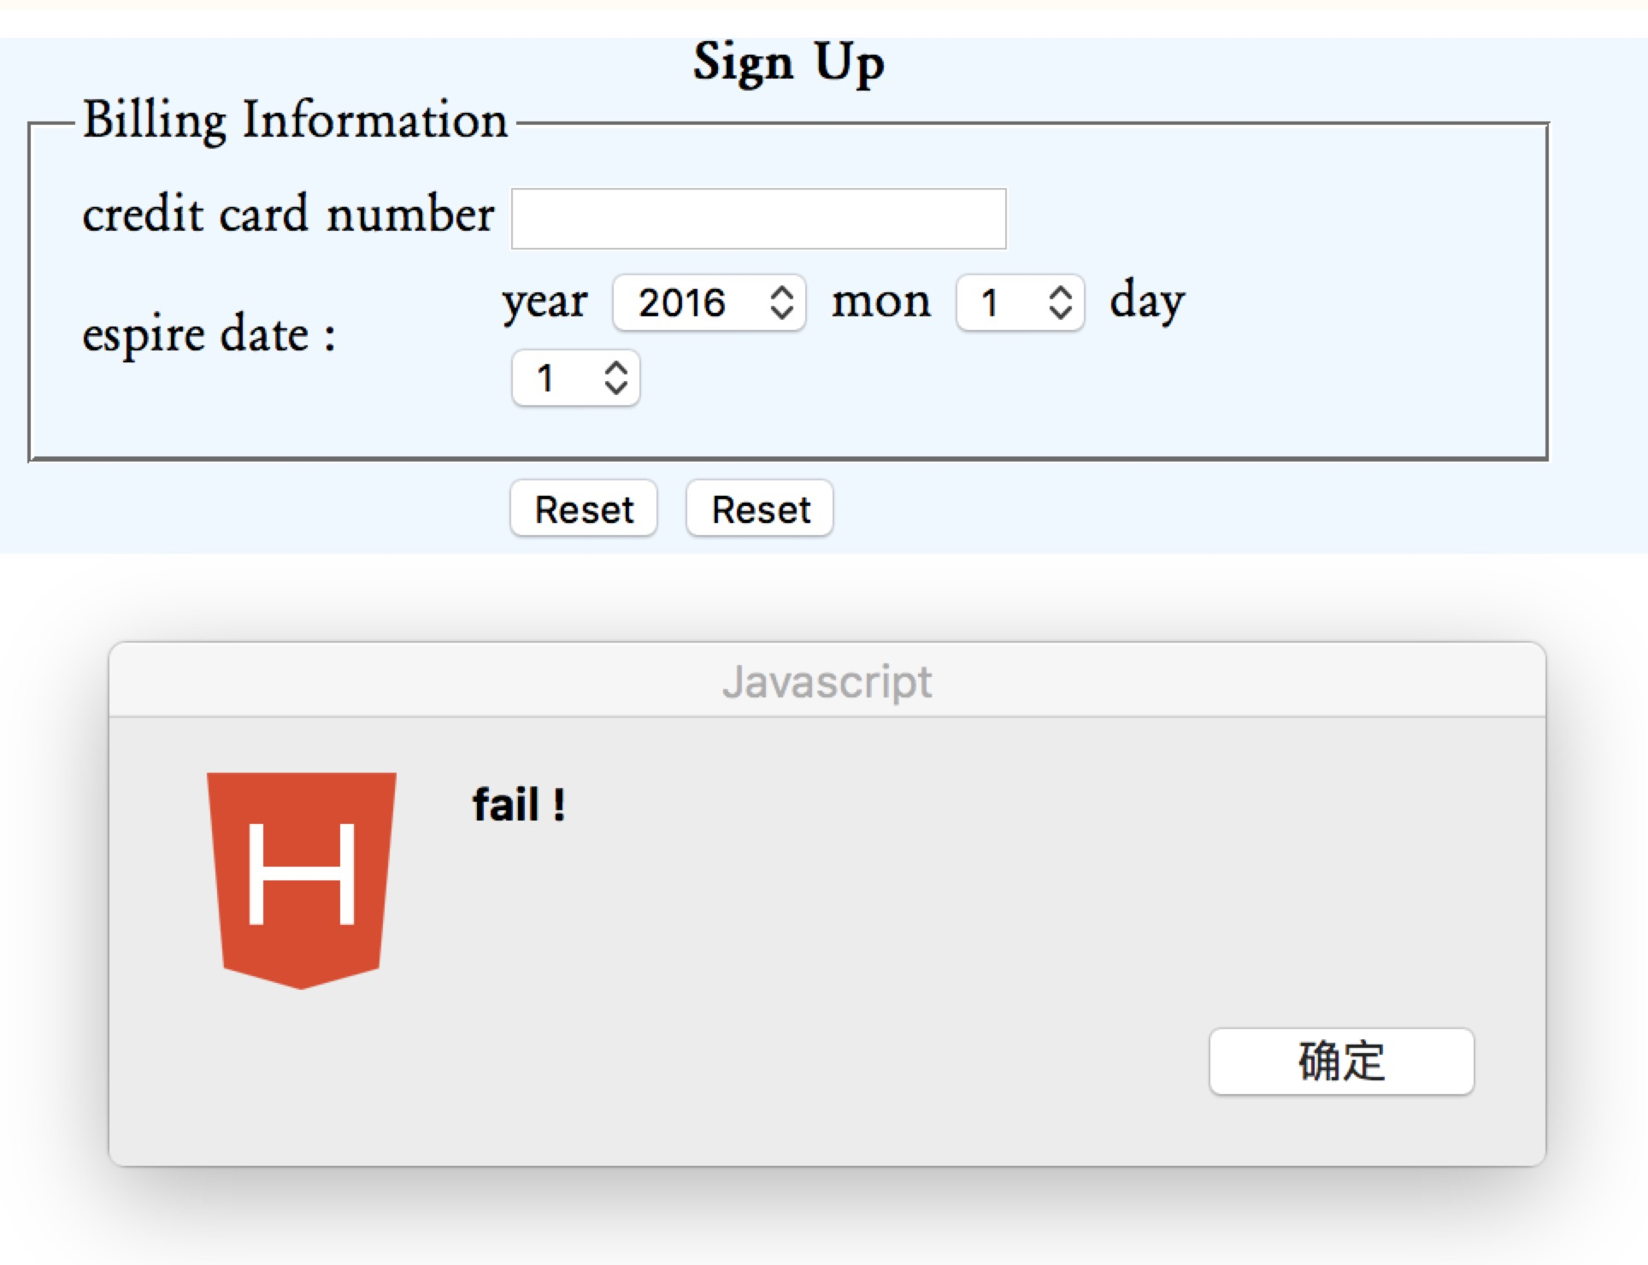

Change password

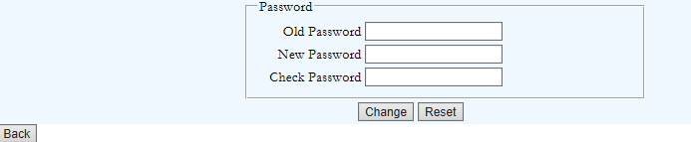

Add new product

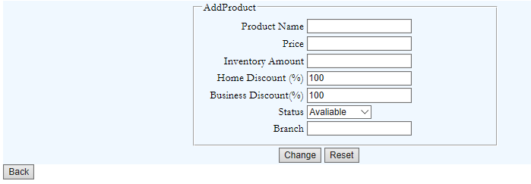

Search products

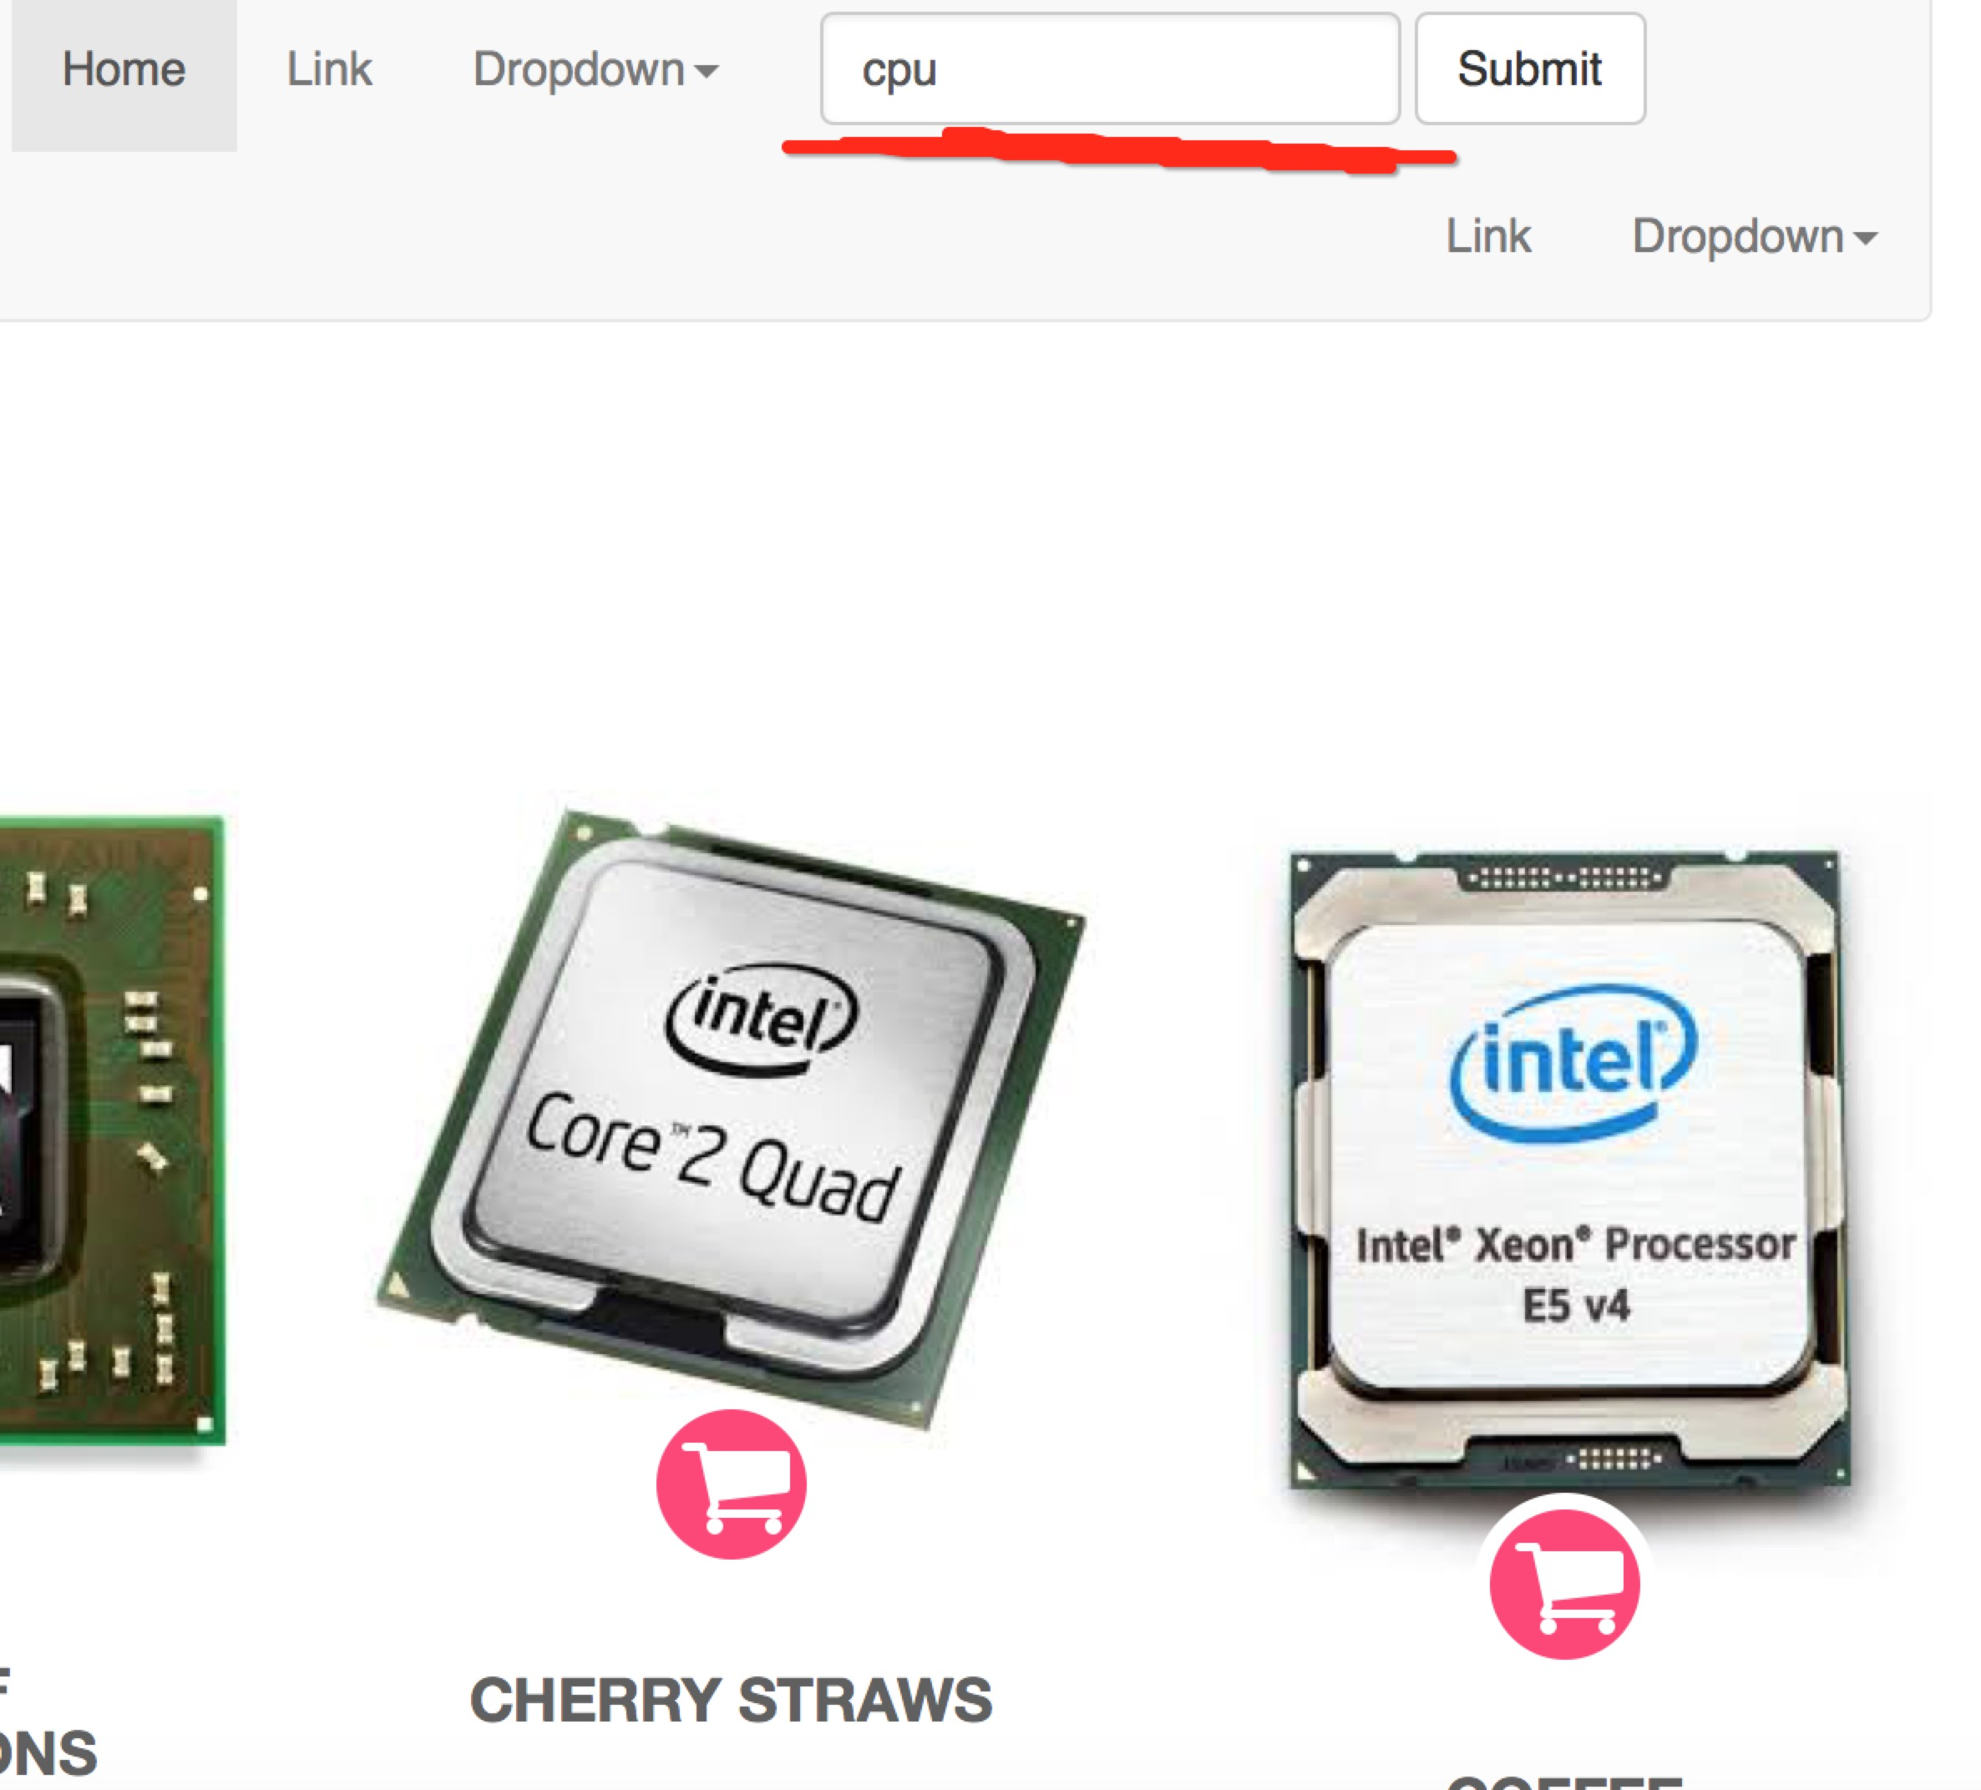

Update products

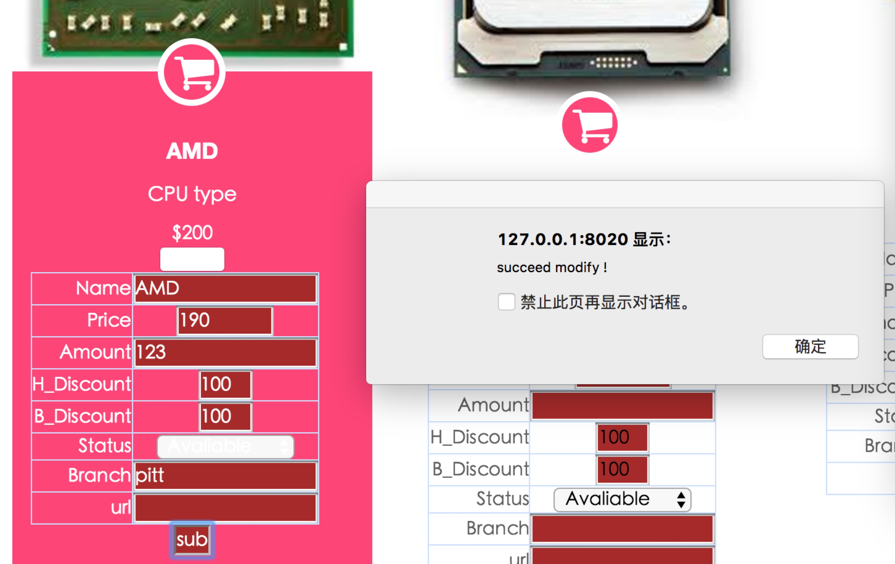

Check out

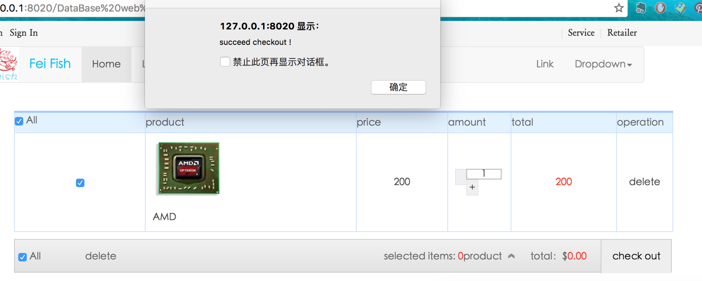

* 1. Test error and erroneous case

Sign in using unusual password

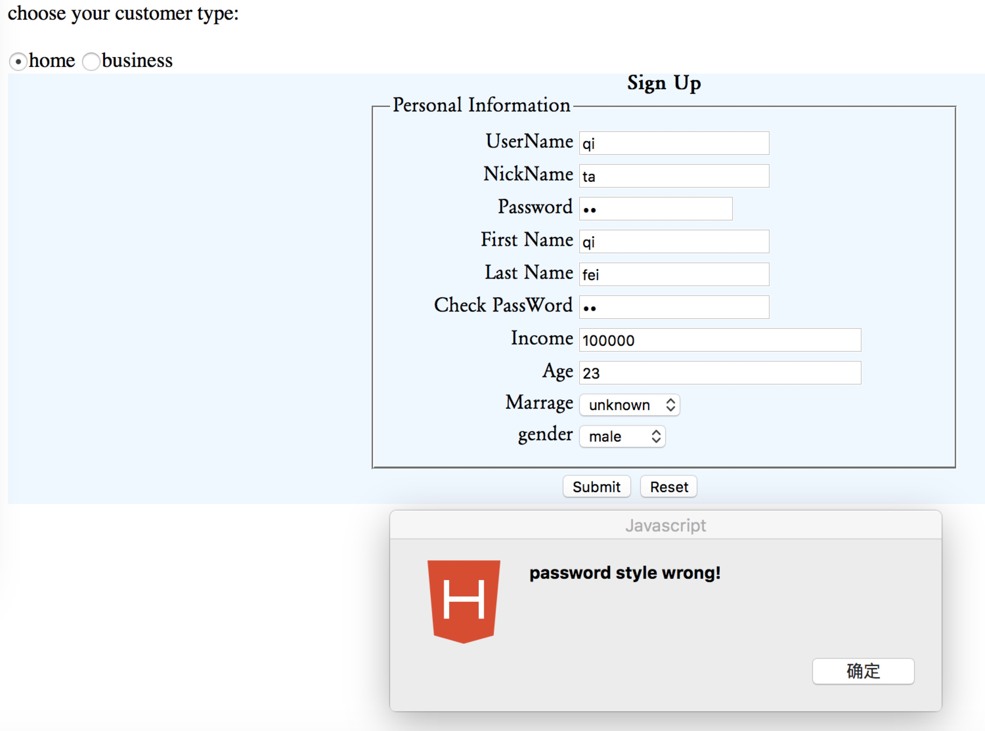

Sign in with negative age

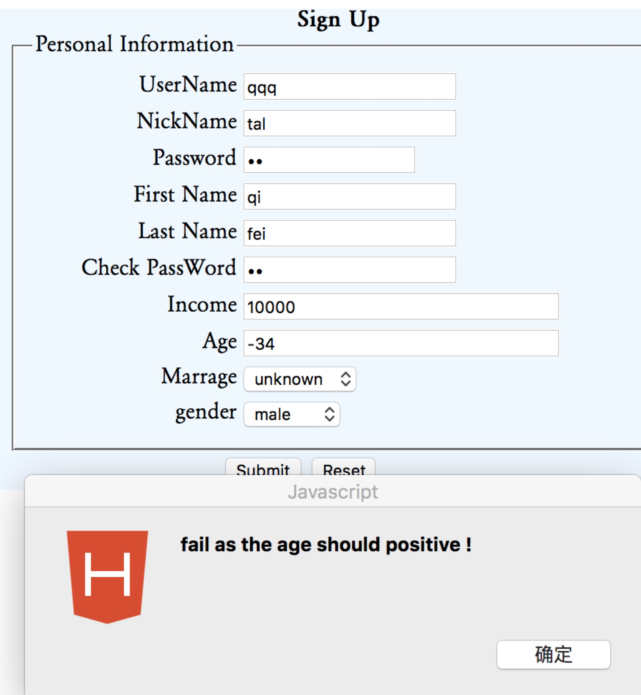

Add address without zipcode

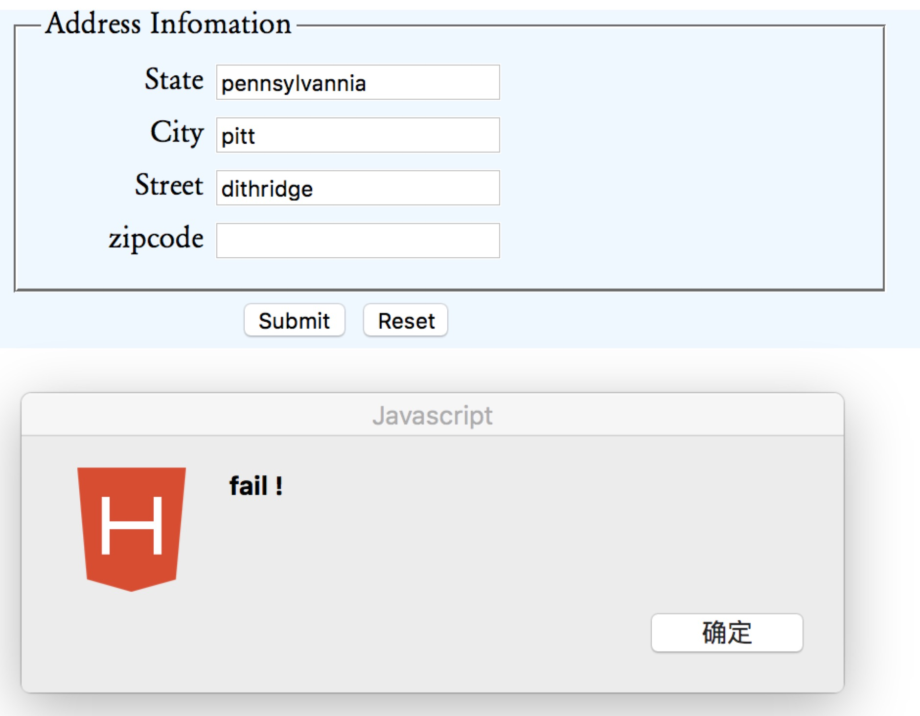

Add billing information with empty credit card number



Update product with empty

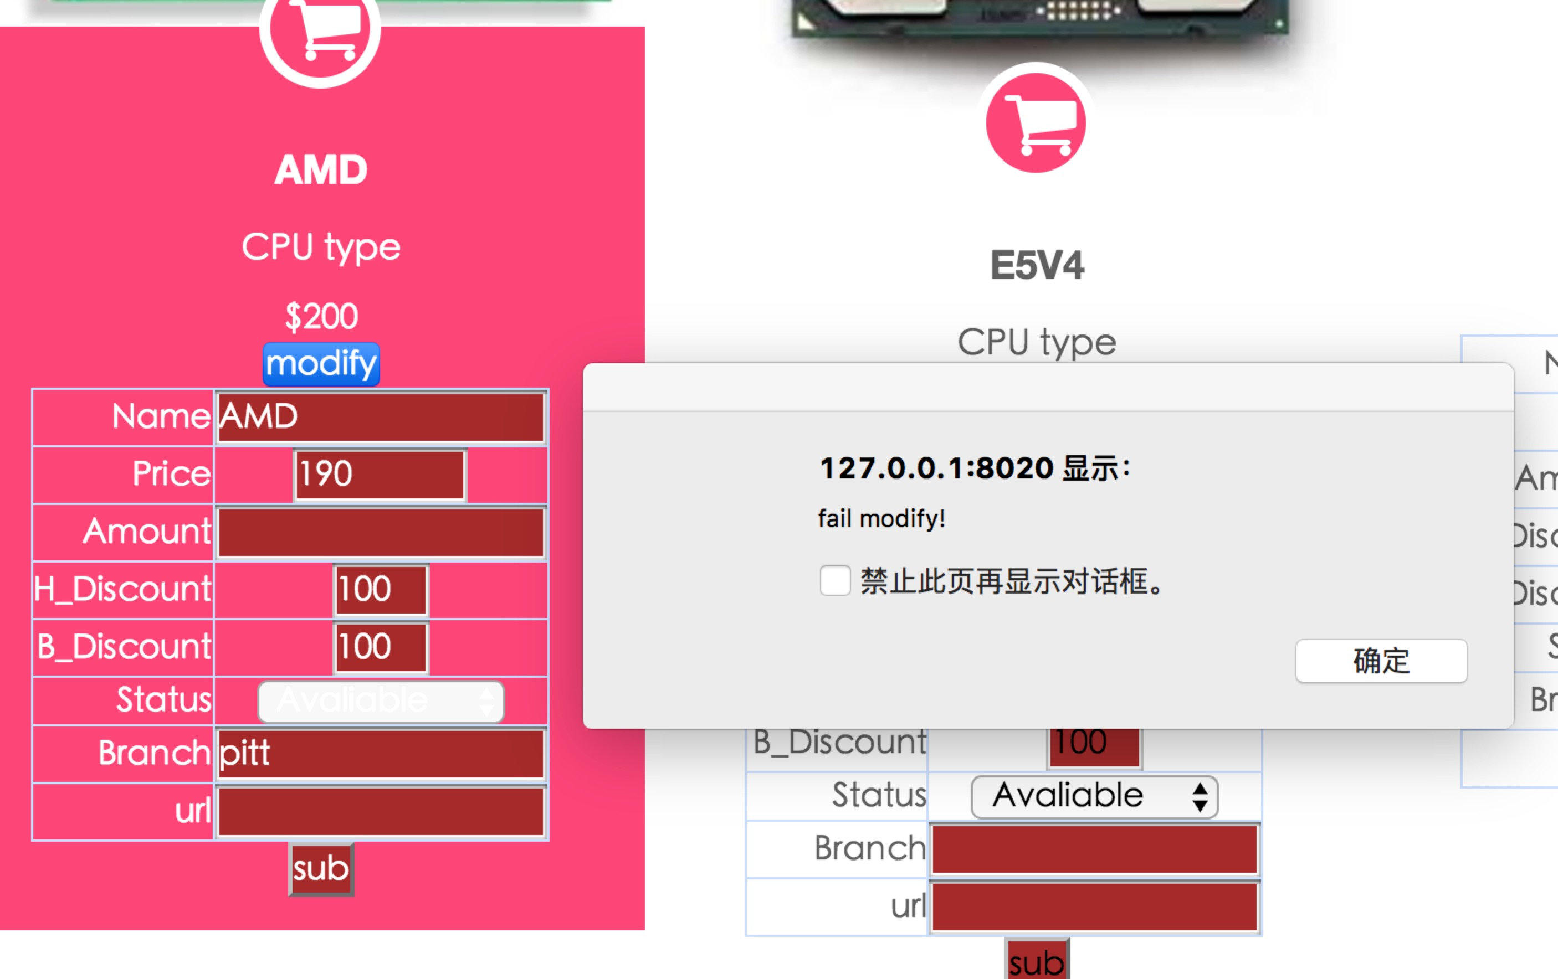

1. Limitation

In our system, users can’t do multiple search and fuzzy search and they can’t give feedback to the products like rate or make comment online. Some outlier can be accepted in our system which require us to do more limitation and check both front and end.